Quiz

Top of Form

**Question 1**(1 point)

*Saved*

**Data can be arranged in ascending or descending order by using**

Question 1 options:

|  |  |
| --- | --- |
|  | Sort command from Table menu |
|  | Sort command from Data menu |
|  | Sort command from Tools menu |
|  | None of these |

**Question 2**(1 point)

*Saved*

What happens when you create a table in Excel?

Question 2 options:

|  |  |
| --- | --- |
|  | Alternate row color banding is added to the table |
|  | Filters are automatically added to the header row (Ans) |
|  | Nothing. You have to set all the characteristics, such as the ones above, manually |
|  | None of the above |

**Question 3**(1 point)

*Saved*

Excel tables come with a new style of formulas called Structured Table Referencing. What happens when a classic A1 style of formulas that you are used to writing is entered in an Excel table cell?



Question 3 options:

|  |  |
| --- | --- |
|  | A1 style formulas are replaced by the new formula style and automatically run down the entire column |
|  | A1 style formulas function as normal, but are automatically run down the entire column |
|  | A1 style formulas can't be used in tables |
|  | Don't know |

**Question 4**(1 point)

*Saved*

**Formatting a range of data as an Excel table can apply color banding and immediately add a name to the table (covering the entire table range), and also add filters. Which outcome is the most difficult to replicate on a range of data not set up as an official Excel table?**

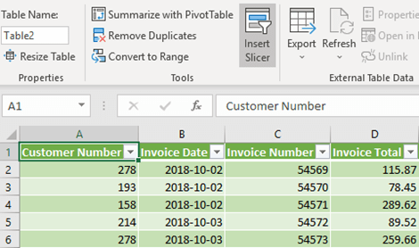

Question 4 options:

|  |  |
| --- | --- |
|  | Adding filters to a list of data |
|  | Alternate row color banding that updates automatically when new rows are inserted |
|  | Ensuring a VLOOKUP is always pointed at the entirety of the target data |
|  | Don't know |

**Question 5**(1 point)

*Saved*

Pre-made sheet formats like Simple, Classic, Accounting, Colorful et can be applied from

Question 5 options:

|  |  |
| --- | --- |
|  | from Fromat >> Cells |
|  | from Format >> Autoformat |
|  | from Table >> Autoformat |
|  | All of above |

Submit Quiz*5 of 5 questions saved*

Bottom of Form